Brain Tumor Segmentation

Yatender
Department of Computer Science and Engineering Technology
Sharda University
Uttar Pradesh, India
E-mail: yatenderkhatri@gmail.com
Rahul Kumar*
Department of Computer Science and Engineering Technology
Sharda University
Uttar Pradesh, India
E-mail:
getrahul33@gmail.com
Jitesh
Department of Computer Science and Engineering Technology
Sharda University
Uttar Pradesh, India
Email: jiteshsingh1089@gmail.com
Prof. (Ms.) Deepti Sahu
Department of Computer Science and Engineering Technology
Sharda University
Uttar Pradesh, India
Email:
deepti.sahu@sharda.ac.in

Abstract— DIP for Medicinal examination is considered as a vital topic for artificial intelligent system. We are introducing a hybrid technique combining K-means and Fuzzy C means clustering algorithms for determining whether a brain MR Imaging scan consists tumor or not. As K-means is a hard clustering algorithm so it is used for initial segmentation via appropriate selection of the image. And after that FCM is used to provide membership to each centroid through the distance between the cluster centroid and cluster data point, prior to obtaining best result. This distance relies upon various factors i.e., contrast, saturation, structure, brightness and homogeneity of the image. Based upon the provided memberships by FCM technique and automated cluster selection a sharp segmented image is obtained. This modified hybrid (hard and soft clustering) approach reduces equipment and operator error. The outcome unveils that such an approach is remarkably encouraging.
Keywords— Fuzzy C means (FCM), Medical Resonance imaging (MR imaging), Digital Image Processing (DIP).

Introduction
Aneurysms, subdural hematomas, ischemia - these are just some of the brain injuries that can cause seizures. A more uncommon but still serious type is called brain tumor. These tumors originate in parts of your brain where thoughts are formed that controls your sense of sight, touch, sound, heat, smoke and that helps you understand speech. There are many types of tumors, but tumors at this level cause seizures, nausea and vomiting, difficulty with visual perception and speech comprehension. Tumor is the result of abnormal growth and cellular proliferation in the brain. If it is not identified earlier and correctly, it may lead to some serious consequences or ultimately death.
MR Images are accepted broadly to diagnose brain tumors. Therefore, improvements to tumor detection and prediction-based systems based on MRI data are needed. But in the early stages of diagnostic imaging such as MR Imaging, appropriate identification of tumor cells and the fragmentation of neighboring soft tissues is a challenging chore that could be due to the existence of low light in thought patterns or maybe complexity and abnormalities, active size and unexpected areas of the lesion.
The detection of autoimmune malformations in the diagnosis of the head tumor on MR Imaging is significant because it comes up with information regarding unusual tissue needed for planning and treatment. Research in recent publications has also reported that automated computer-assisted diagnosis and diagnosis based upon medical image assessment, could be an effective substitute as this could save a radiologist's time and regain established precision. In addition, if computed algorithms can provide robust, multidimensional tumor estimation, this automatizes the capacities which will be of great assistance in clinical administration of tumors by setting physicians free from burden of tumor exposure.
Segmentation of flat or bidimensional images under binary partitioning approach is possible by thresholding. But by cause of complicated structure its next to impossible to achieve a proper and unbiased threshold. Also, the limitations which comes up with thresholding are that, it can’t be associated with colored or multi-channel images and its very much noise sensitive (noise makes thresholding value biased). For improved and unbiased thresholding values we used restrictions like Classifiers and Clustering Methods (soft and hard clustering). Using some predefined image related criteria (like intensity and other details) we extract homogenous patches in region growing. Although a manual interaction is needed for finding seed pixels which comes out to be the primary limitation for it and when these seed pixels come together with their neighbors and associate refers to region growing. Scarcity of training data while using classifiers will result in over consumption of time and unexpected results. While using FCM it will firstly segment the image, then an expert system will locate lesion by matching them to the previous learnings. Traditional FCM is sensitive to noise. However, K-means is affectless of noise, but it needs perfect thresholding that’s a bit difficult to attain.
On the basis of foregoing exploration, it can be considered that keeping down the limitations of each mechanism could give optimum results.
Within this paper, we are putting forward a contrasting hybrid technique consisting of FCM and K-means approach. It minimizes the issue of noise sensitivity associated with FCM and grey level selection. Included pixel intensity is very low as we used intensity-based pixel positioning approach in K-means clustering implementation. Updated membership (based on various image features i.e., contrast, intensity, etc.) and filtered image’s cluster numbers are the basis for FCM algorithm modification.
Throughout this project we are using the Brain MR images with Axial view just because its symmetric and gives visuals of whole brain at once.
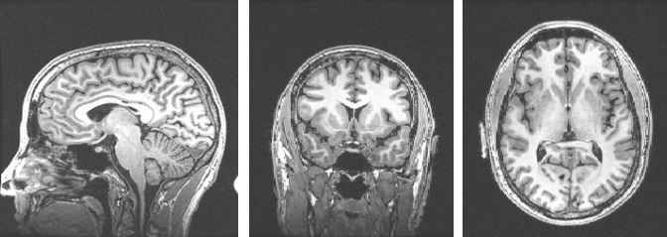
Fig. 1. Brain MR images captured from different angles i.e., Sagittal view, Coronal view, Axial view, respectively.

Related Works

Segmentation or breakdown of a medical image to identify brain tumor by any medical imaging technique is very important practice for determining appropriate treatment in a timely manner. Many brain tumor segmentation techniques in MR images have been suggested, in particular, Support Vector Machine (SVM), Fuzzy C means (incomprehensible integration techniques) (FCM), artificial intelligence, Computational Neural networks, knowledge-established techniques, and the Expectation Enhancing process of algorithm which is highly used technique used for region-based classification as well as extracting important information from medicinal images.

D. Raghavan [30] et al. (2015) designed an approach based upon neural network using various classifiers for classification and segmentation of White Matter, Cerebrospinal Fluid and Gray matter, and tumor affected regions and claims to acquire 83% accuracy.
Zanaty (2012) developed a hybrid approach for tumor segmentation combining FCM, Jaccard similarity coefficient and seed region growing algorithm for segmentation measurement of white and grey matter from test MR images. We also tried this approach of using hybrid algorithm but with different algorithms to get maximum accuracy. This technique obtained more than 85% score in segmentation at reasonable noise levels.
Karnan et al. (2010) used some clustering algorithms for the brain tumor classification [24]. Even after using Genetic Algorithm as the Optimization tool for improved results this approach achieved approximately 75% accuracy with minimal error values (neighboring values to zero) [24].
Deng et al. [39] proposed method of discriminative clustering and approach of future selection for automated brain tissue segmentation using MR images of brain.
Mahmoud et al. [9] proposed an automatic tumor region identification technique via MR images. The classification has been done on the basis of type of tumor, whether the tumor is benign or malignant. Computational Neural Network techniques were used for these classifications, segmentation and feature extraction. In the end, region interest techniques were taken for tumor localization.
Koley et al. (2011) implemented CSM (Cohesion Based Self Merging) algorithm for locating the tumor’s exact region. CSM algorithm was used because its computationally less complex and also for satisfactory results as compared to hybrid merged processes [18].
Colliot et al. [14] chose 3D MR images for segmentation. Their approach can be used on various kinds of tumors. In beginning, segmentation was done using the proposed approach. Then lesion selection has been done through FCM classification.
Lin et al. (2008) proposed a hybrid approach of watershed algorithm minimizing unnecessary excessive segmentation. Furthermore, improvement is done via collaborating another algorithm with the watershed to enhance segmentation quality. Performance assessment of the suggested method is done on the grounds of image quality and qualitative validation [36].

The survey of the above texts has revealed that some strategies are developed to obtain only classification; some strategies are developed to detect the extraction factor and some strategies are developed to obtain the segmentation only. Vector Reduction and Feature extraction for the functional segmentation of CSF, GM, WM, infected brain region, and integrated method analysis were not performed in any of the available litreray works. In addition, only a few capabilities have been hauled out and therefore precision obtained in plant recognition is quite low. Also, all of the above literature missed dice similarity index (calculation of overlapping), which is a significant indicator for the precision of a brain tumor classification algorithm.

In earlier brain tumor-related studies, algorithms have used classic and standard methods like edge detection and region growing techniques for image processing. In recent years, segmentation and classification became possible through learning via supervised and unsupervised techniques for instance k-means, Support vector-machine (SVM), ANN, and for latter Fuzzy C-means (FCM) [10].
In this study, we proposed a hybrid algorithm strategy combining two algorithms: Fuzzy C-Means (FCM) and K-means (well tested by us through various studies). The aim of this research is to draw out information by segmenting images consisting tumors and to identify the tainted tissues by comparing test images with a huge dataset of resonated images. Outcomes of our research results into the belief that the preferred approach should combine clinical decision-making systems for primary diagnosis, analysis done by clinical specialists or radiologists.

Mr image segmentation techniques

Region growing-
This technique initiates with a point called seed pixel and grows the region by adding the pixels neighboring to it based on a specific threshold value. When the growth of a region stops, another seed pixel that does not belong to any other region is chosen and the process is repeated until all pixels belong to some region. Some major issues related to this method are: Noise sensitivity, occasionally manual interaction is required for seed pixel selection.

K-means-
It is the most important clustering and the simplest unsupervised learning algorithm. In this algorithm ‘K’ centers are defined around which clusters will be formed. Then take the neighboring point and making it accomplice to the nearest centroid and repeat this till every point isn’t connected to some center. The sole purpose of this process is to lessen the sum of distances amidst the data point and their clusters they akin to [15].

Fuzzy C-means (FCM)-
This gives the fuzzy values of any specific data point to be present in either of the clusters. In this method, we need to find the centroid of the data points and then measure the distance for every data point from the given centroid until the clusters formed become constant.

Support Vector Machine (SVM)-
SVM algorithm lies under the umbrella of Supervised Learning algorithms. The sole intent of this method is to classify the decision boundaries, segregating the data points within appropriate groups. It selects the most extreme places to aid in the formation of these boundaries.

Artificial Neural Network (ANN)-
Initially, an image is plotted onto a Neural Network. Here each Neuron stands for some pixel. The Neural Network will be trained with a training sample set in contemplation to regulate the connection and weights among the nodes [15].

Hybrid Techniques-
This literature describes a number of hybrid ways for analyzing magnetic resonance brain images. E.A. Zanaty (2012) used a hybrid strategy for tumor segmentation that combines FCM and the Jaccard similarity coefficient, which worked well and scored about 85 percent in segmentation [12].

Proposed Model
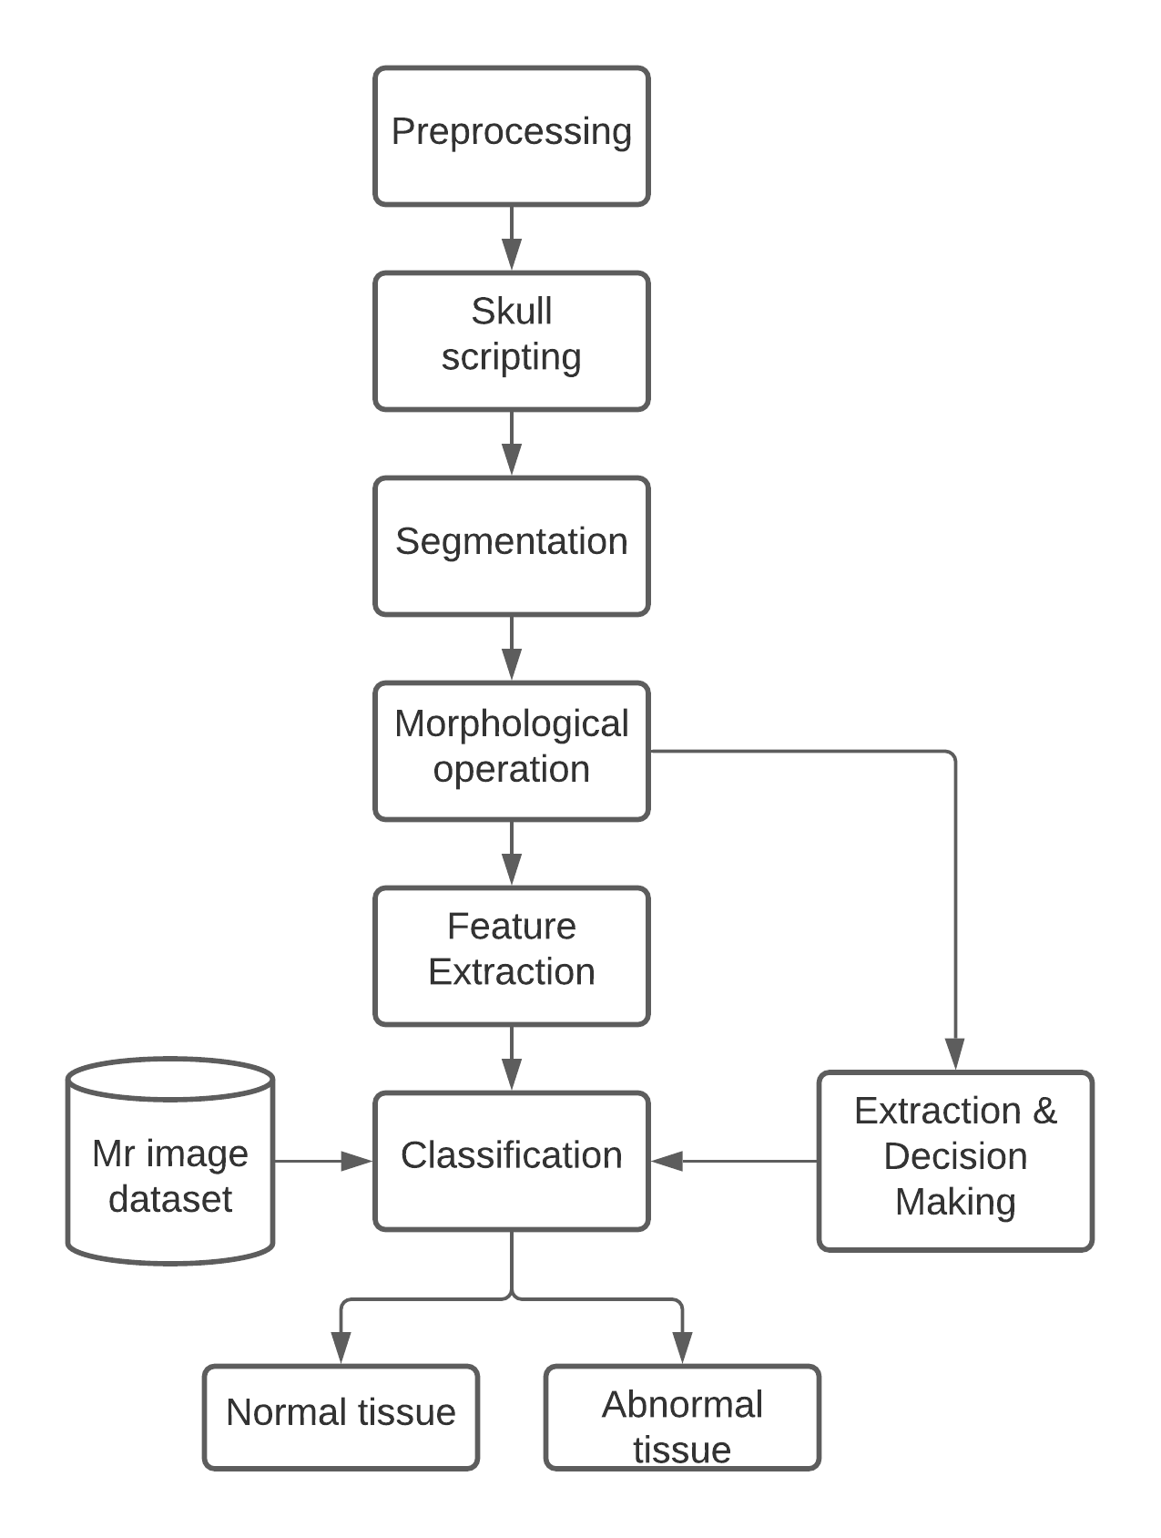
Fig. 2. Steps used in the proposed method

Proposed method
Within this paper, we used multiple techniques to come up with the optimal result within the least time. Every step of this process is carried out via different techniques – those techniques are referenced below:
- Gray scaling the test image: To get better differentiation of lesion across the whole image we use this technique, otherwise, if we skip this lay then we need to use CNN or Deep Learning.
- Preprocessing: The main task of pre-processing is to improve the appearance of test images and to craft them for extended administration by a human or machine visual system. Furthermore, advanced processing assists in image spectrums improvement such as signal to noise ratio, removing unnecessary noise, appearance, and unwanted overlapping background parts, and maintaining its edges.
- Using Centre Crop augmentation: Crops are used to obtain better segmentation results. Built with an image size of (96 * 96) from a 189 * 233 database. This database will be generated as an original image patch by cropping the image from the center in size 96 * 96. This procedure is used to remove hippocampus pieces as wells as sideways tumors near the skullcap.
- Image Segmentation: Segmentation is used to find the boundaries and objects in the images. Within the First Division, the pre-processed brain plotting is transformed into a binary plotting with a threshold value of 128. All the pixel values more than the threshold are plotted white, and remaining pixels are marked black; as a result of these two values, separate regions are formed around the tainted tissue region. Then in interest of wiping out the white pixel, the morphology erosion function is performed. At last, the operated zone and the first image are both separated into two equal sections and the area of ​​the dark pixel drawn by the erode function is conceived as the Magnetic Resonance image’s mask of the brain.
The K-Means Clustering Technique is used to carry out the segmentation procedure. It defines 'K' centers, one for each cluster. These groups must be separated by a large distance. The next stage is to associate a point from a specific data collection with the nearby center. When there are no unsettled points, the first step is over, and early grouping begins. The second step is to recalculate 'k' new centroids as the barycenter of the clusters created in the first phase. In Subsequent addition of 'K' new centroids, a new binding amidst the identical data set points and the nearest new center is required. There has been created a loop. As a result of this loop, the k centers gradually shift their locations until they no longer move.
FCM (Fuzzy C-means) - Based upon distance among data points and the cluster center, this method awards membership to individual data points referring to each cluster center. Datapoint closest to the cluster center has a higher percentage of members who belong to that center.

- Lesion Detection / Features Extraction: Brain damage is a defect seen within brain test images, such as Computed Tomography (CT) or Magnetic Resonance Images (MRI). Feature Extraction helps locating brain tumors and assists in predicting their next stage. Feature extraction falls under the dimensionality reduction process, within which, the first set of raw data is split and shortened to various untroublesome groups. So, its processing becomes much easier. Having a wide range of variables is a vital characteristic of these large datasets. Large computing resources are required to process these variables. Therefore, feature extraction helps in obtaining the finest features from big datasets by selecting and integrating variables into features, thus, effectively lowering the amount of data. When the primary analysis and the desired degree of classification (line, word, character, or symbol) have been achieved, another feature removal method is used in components to determine the features, post-processing techniques, and followed classifications. It is imperative to emphasize the exclusion factor as it has a significant impact on the competence of the recognition system. Taking all mentioned factors into account, it’s necessary to consider the numerous techniques available to extract features in a given domain, which consist of greater litigation chances. Feature extraction in this paper is achieved by using-
- Thresholding
- Contrast: Foreground and Background

Conclusion
In this proposed work various medical images like brains MR tumor and cancer images are taken for detecting the tumor. The proposed approach utilizes a mixture of various different Machine Learning techniques and consists of several steps including training the system, pre-processing, segmentation, classification, and feature extraction. For achieving the optimum results, we tried minimizing the limitations of each technique used. Initially K-Means algorithm is used for segmentation via appropriate selection. Implementing the K-means clustering through Intensity-based Pixel Positioning to not avoid even least amount of pixel intensity. Minimizing the noise sensitivity associated with image for FCM algorithm. Updated membership is attained by distance measurement between cluster and centroid. This measurement/membership distribution is done till optimal results are achieved. Accuracy and other results show that this approach is better than other various hybrid approaches used previously. Additionally, classifier boosting techniques can be employed to improve accuracy even further and reach a degree that allows the tools in becoming an indispensable asset in any neurological institution that deals with brain tumors.

References
- Angelini E D, Clatz O, Mandonnet E, Konukoglu E, Capelle L, Duffau H. “Glioma dynamics and computational models: A review of segmentation, registration, and in silico growth algorithms and their clinical applications.”
- Ali Isin, Cem Direkoglu, Melike sah, “Review of MRI-based brain tumor image segmentation using deep learning methods.”
- Amy Zhao, Guha Balakrishnan, Fredo Durand, “Data augmentation using learned transformations for one-shot medical image segmentation.”
- Anitha V, Murugavalli S., “Brain tumor classification using two-tier classifier with adaptive segmentation technique.”
- Anusree P S, Reshma Raghunath, Saritha KS, “MRI Brain Image Segmentation using Machine Learning Techniques.”
- Badran, E.F., Mahmoud, E.G., Hamdy, N (2010): "An algorithm for detecting brain tumors in MRI images", Proceedings of the International Conference on Computer Engineering and Systems (ICCES), Cairo, pp: 368 - 373.
- Bauer S, Wiest R, Nolte L, Reyes M., “A survey of MRI-based medical image analysis for brain tumor studies.”
- D.Selvaraj, R.Dhanasekaran (2013): “MRI Brain Image Segmentation Techniques – A review.”
- E. A. Zanaty, “Determination of gray matter (GM) and white matter (WM) volume in brain magnetic resonance images (MRI),” International Journal of Computer Applications, vol. 45, pp. 16–22, 2012.
- Hassan Khotanlou, Olivier Colliot, Jamal Atif, Isabelle Bloch, (2009): "3D brain tumor segmentation in MRI using fuzzy classification, symmetry analysis and spatially constrained deformable models", Fuzzy Sets and Systems, Vol: 160, No: 10, pp: 1457-1473.
- Jonathan Morra, Zhuowen Tu, Arthur Toga, Paul Thompson, “Machine Learning for Brain Image Segmentation.”
- Koley, S., Majumder, A (2011): "Brain MRI segmentation for tumor detection using cohesion based self-merging algorithm", Proceedings of the IEEE 3rd International Conference on Communication Software and Networks (ICCSN), Xi'an, pp: 781 - 785.
- M. Aarthilakshmi, S. Meenakshi, A. Poorna Pushkala, V. Rama@Ramalakshmi, N.B. Prakash, “Brain Tumor Detection Using Machine Learning.”
- Mahmoud Al-Ayyoub, Ghaith Husari, Ahmad Alabed-alaziz (2015): “Machine Learning Approach for Brain Tumor Detection.”
- Mirajkar, G., Barbadekar, B (2010): “Automatic Segmentation of Brain tumour from MR images using undecimated wavelet transform and Gabor wavelets,” IEEE international conference on Electronics, circuits, and systems.
- N. N. Gopal and M. Karnan. Diagnose brain tumor through MRI using image processing clustering algorithms such as Fuzzy C Means along with intelligent optimization techniques. In IEEE International Conference on Computational Intelligence and Computing Research (ICCIC), pages 1–4, Dec 2010.
- Nilesh Bhaskarrao Bahadure, Arun Kumar Ray, and Har Pal Thethi (2017): “Image Analysis for MRI Based Brain Tumor Detection and Feature Extraction Using Biologically Inspired BWT and SVM.”
- Othman, M. F. B., Abdullah, N. B. Kamal, N. F. B (2011): “MRI brain classification using Support vector machine,” IEEE, Centre for Artificial Intelligence & Robotics (CAIRO), Universiti Teknologi Malaysia.
- S. Damodharan and D. Raghavan, “Combining tissue segmentation and neural network for brain tumor detection,” International Arab Journal of Information Technology, vol. 12, no. 1, pp. 42–52, 2015.
- S.M. Ali, Loay Kadom Abood, and Rabab Saadoon Abdoon, “Brain Tumor Extraction in MRI images using Clustering and Morphological Operations Techniques”: International Journal of Geographical Information System Application and Remote Sensing Volume 4, No.1, June 2013, ISSN 2077-771x; ICSRS publication, 2013.
- SivaSankari.S, Sindhu.M, Sangeetha. R, ShenbagaRajan (2014): “Feature Extraction of Brain Tumor Using MRI”, Vol: 3.
- Stefano Cerri, Oula Puonti, Dominik S. Meier, Jens Wuerfel, Mark Muhlau, Hartwig R. Siebner, Koen Van Leemput, “A Contrast-Adaptive Method for Simultaneous Whole-Brain and Lesion Segmentation in Multiple Sclerosis”, pp. 6.
- Yang, Weidong Zhao, Li pan (2008): “An Improved clustering algorithm based on Ant-Tree,” IEEE, 2008

